10 Fitness Myths

Beyond Fit

Did you know that every 5 minutes, a new fat loss theory is created?

OK, that’s not an actual stat but it feels pretty accurate, doesn’t it? It seems that every year, the right way to lose fat undergoes a radical evolution. While eating a liquid-only diet and jogging in sweat suits were once the go-to approach, today’s proven methods of fat loss are much different – and thankfully proven by science.

In this guide, we’ll separate fat loss fact from fat loss fiction and highlight 10 of the biggest myths that still seem to find their way into our lives.

Please enjoy and apply to the new and improved year of 2015!
- The Beyond Fit Staff

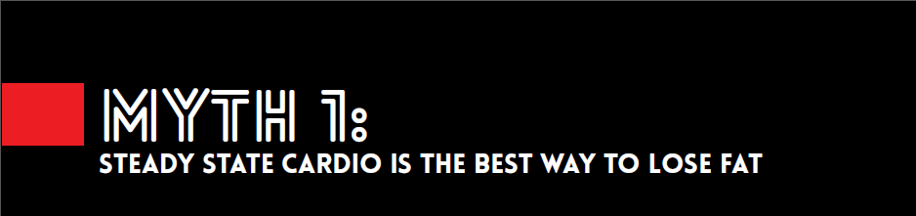
Steady state cardio is what most of us think of when we hear the word “cardio” - it’s trudging around at a slow jog, or galloping nowhere on an elliptical for 30 minutes or more. It’s probably the biggest reason why people hate exercising, and with good reason! Steady state cardio is boring.

But we have some good news for you. It’s also not the best way to lose body fat.

“Back in 1992, it was understood that if you wanted to be lean . . . you had to do cardio – hours of it,” says fitness guru Lou Shuler who co-wrote The New Rules of Lifting Supercharged.
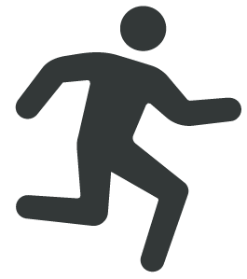
Then in the early 2000s, a number of studies like Izumi Tabata’s (who popularized the Tabata style workouts which we do at our box) told us that short intense interval workouts can produce similar results to longer, slower cardio workouts in a much quicker time.

Boot Camp, Cardio Conditioning and other forms of HIIT (high intensity interval training) are two ways you can lose body fat in less time and actually have fun doing it.
I don’t know about you, but we’re quite happy to know that it isn’t necessary to graze on 6-7 small meals a day to lose body fat.

Who has time for that anyway? Bodybuilders and figure competitors. That’s who.
Sure, it’s hard to argue with bodies like theirs that this technique belongs on a list of myths. But it’s even harder to argue with the research that tells us that there’s no evidence that our metabolism decreases if we only eat 3 meals a day.

Not only is there no proof that grazing helps you lose body fat, some say it can actually inhibit your ability to burn fat. When you’re constantly eating, you’re constantly releasing insulin which stores sugar and keeps other enzymes in your body from breaking down fat.

Plus, eating small meals throughout the day will leave you feeling unsatisfied which can drive even the most level headed of us a little diet crazy. Bottom line, you can continue to eat like a human and leave the grazing to the cows.
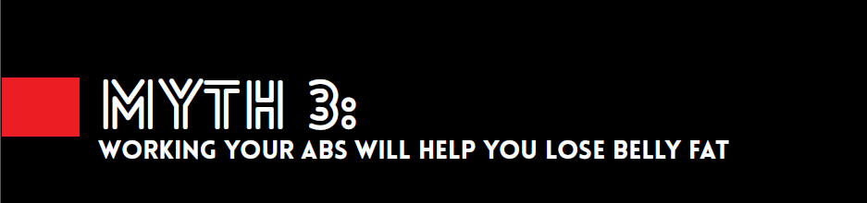
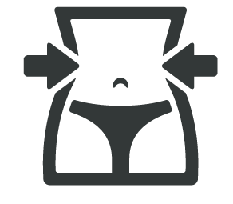
An oldie, but a goldie, and the #1 myth that just won’t die: “If I do ab exercises, I’ll finally see my six-pack.”
Well, the reality is, you already have a six-pack. It’s what keeps your body from flopping around like a whacky waving inflatable arm tub man. The problem is, there’s a bit of chub hiding it.

Doing more crunches and leg lifts won’t slim you down. In fact, it may make you appear larger as you build out those muscles.

The secret to showing off those six-pack abs is cleaning up your diet by cutting out sugar (especially alcohol), drinking more water, reducing the amount of salt you consume, saying no to dough and adopting a training routine like we do here.
Get Beyond Fit!
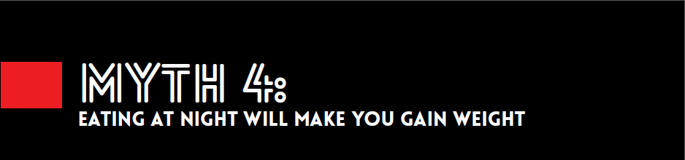
Eating at night will not make you fat. However, eating junk at night will which is why this myth still exists today.

Most people with health on the brain start the morning on the right foot. They have the perfect breakfast, bring the healthiest lunch and snacks to work, but when they get home from a long day and it’s finally time to relax – well, that’s when the junky munchies kick in. You know what they say, “idle hands are the Devil’s playthings.”

We haven’t yet figured out how to cure the late night cravings, but a good preventative move is to clean your kitchen out of sweets and other guilt inducing treats.

If you reach for the right meal to snack on when you’re relaxing on the couch, your body will store no more of that fuel as fat than if you were to eat it at 9am.

When most people think about training with weights, they immediately think of those slow and steady bodybuilder style workouts. While heavy strength training can help you lose body fat too, to unlock the real body fat loss potential, you’re going to want to combine high-intensity intervals with changing movement combinations using dumbbells, kettlebells, and barbells like we do here during our Beyond Fit works.
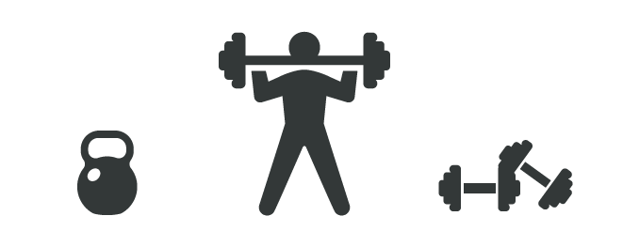
Lifting weights this way becomes less about how much weight you can lift, than it is about how you can make your body more efficient, lean and strong.

Plus, your body burns more calories maintaining muscle than it does maintaining fat, which means the more muscle you build, the more calories your body will burn at its resting state.
Try Beyond Fit!

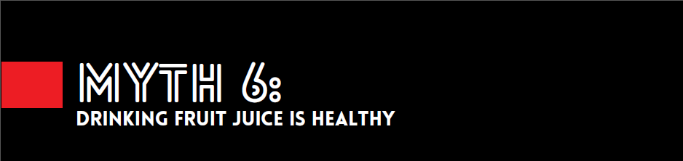
“So I can’t drink alcohol. I can’t drink soda. And now you’re telling me I shouldn’t have orange juice either?!”

Unfortunately, yes. We’re putting fruit juice in the same category as Mountain Dew.

“Fruit juice isn’t the same as intact fruit and it has as much sugar as many classical sugar drinks,” says Susan Jebb, a government advisor and head of the diet and obesity research group. “It is also absorbed very fast, so by the time it gets through your stomach, your body doesn’t know whether it’s Coca-Cola or orange juice, frankly.”

It also turns out that some of the more popular fruit juices contain no actual fruit at all.

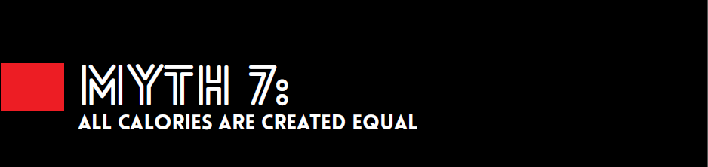
The human body is a highly complex system, so to say that all you need is to burn more calories than you consume seems a little ridiculous, doesn’t it?

Here’s an example of why this is a major myth that should be squashed immediately with a giant hammer: Calories from whole foods are less fattening than calories from processed foods because they take more energy to metabolize. This means, that if you have two sandwiches: 1) made with whole grains and cheddar cheese, and 2) made with white bread and processed cheese, you’d burn more calories by digesting the whole grain sandwich.
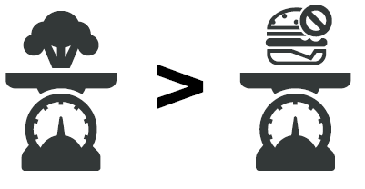

Protein calories are also less fattening than calories from carbs and fat, so if you consumed some chicken with the caloric equivalent of the whole grain cheese sandwich, you can guess which would result in more calories burned.
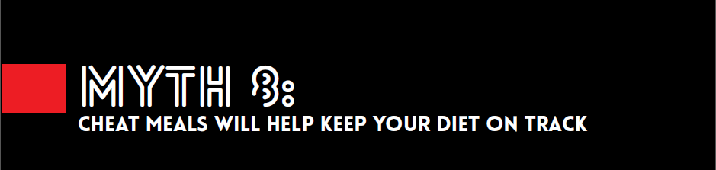
Cheat meals are supposed to prevent you from feeling deprived and increase your chance of success on a diet – and for some people, this strategy works. But for most of us, pigging out on harmful foods just isn’t a good idea.

Think of your addition to cheat meals as if you were addicted to a less socially acceptable vice – let’s say alcohol. Do you think that Alcoholics Anonymous is encouraging their members to knock back a martini every week to remind them what it was like to really live? No. That would be feeding their addiction and just keeps their unhealthy habits going.

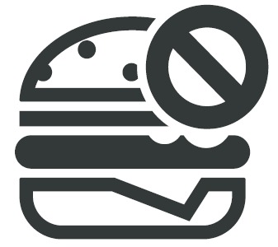
If you allow yourself a cheat day every week, you’ll naturally be craving that cheat day all week, whereas by avoiding certain foods completely, your cravings will diminish with time.

When you work out alone, it becomes just that – work. But when you train with a group of positive people who are there to make themselves better too, it can become quite the opposite.

At Beyond fit, it’s almost impossible not to foster an emotional connection with the other members and coaches.

And because we’re all having such a good time, it encourages you to skip less training days because the gym is where you really want to be.
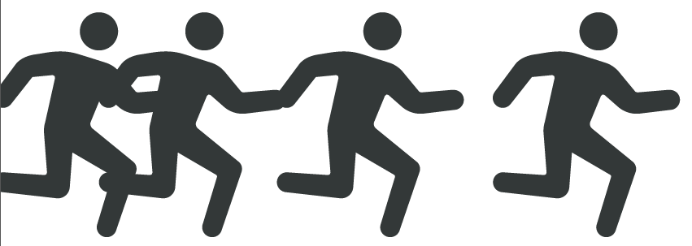

Try Beyond Fit Online

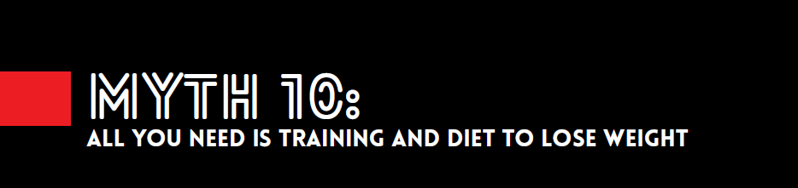
Isn’t consistent training and a good diet the key to losing body fat?

False!

Consistent training, a good diet and adequate sleep is the equation for fat loss. It’s hard to believe that something you do when you’re not even awake can be the last (and maybe most important) ingredient in getting the body you had always wanted, but it’s true.

Without proper sleep, your cortisol levels increase which causes anxiety and weight gain. We need healthy levels of cortisol, but when they’re out of whack, this can do some nasty stuff to your body.
So . . .
Like what you’ve read?
Maybe it’s time to give us a try.
Click here to try Beyond Fit online

Just think of this as your ticket to a happier, healthier
lifestyle from all of us!

